website project proposal 2
[Document subtitle]
Joseph Monnamoholo Moreki
[Company name] [Company address]

PROPOSAL 2: Karabo Nail Bar and Hair Salon

Contents
1. Organisation Overview 1
2. Website Goals and Objectives 1
3. Current Website Analysis 2
6. Technical Requirements 4
7. Timeline and Milestones 4
8. Budget 5
SITEMAP — Karabo Nail Bar and Hair Salon 5
9. References 6

Organisation Overview

Karabo Nail Bar and Hair Salon is a thriving beauty business that has served its local community with passion and professionalism.
Recognising the growing need for a professional digital presence, Karabo seeks to launch an informational website. This website will act as a public online portfolio for the salon, allowing visitors to view services and products, but will not include any functionality to purchase or pay for anything online.
Mission Statement
To provide exceptional beauty services and quality products that inspire confidence and celebrate the beauty of every individual.
Vision Statement
To grow into a recognised beauty brand with a strong online presence that informs and attracts clients across South Africa.
Target Audience
- Beauty enthusiasts aged 18–45 searching for salon services online
- Existing clients looking for information about services and opening hours
- Potential new clients researching the salon before visiting
- Anyone looking for professional hair and nail care advice

Website Goals and Objectives
Goals
- Launch a professional, modern informational website for the salon
- Extend brand visibility beyond the local community
- Provide clear, accessible information about all salon services and products
- Encourage potential clients to contact or visit the salon in person
- Establish a foundation for future digital marketing
Key Performance Indicators
- Unique website visitors per month
- Enquiry form submissions
- Average time spent on website
- Search engine ranking for local salon searches
- Newsletter subscription growth
A strong professional digital presence significantly increases brand awareness and drives foot traffic to physical business locations. (Kotler et al, 2022)

Current Website Analysis
Karabo Nail Bar and Hair Salon currently have no public website. This means the business is almost invisible to anyone searching online for salon services and is missing a very large opportunity to attract new clients.
Identified Weaknesses
- No online platform to showcase services or work
- Brand reach is limited only to people who already know the salon exists
- No digital marketing foundation
- No easy way for potential clients to find contact information or opening hours
Proposed Solution
Build a simple, high quality informational view-only website.

- Proposed Website Features and Functionality
Page | Description
Homepage | Welcome banner, salon introduction, featured services and latest updates
Services | Full list of all hair and nail services offered, with pricing information for reference
Products | Visual showcase of all products used and recommended by the salon, for viewing only
Gallery | High quality photo portfolio of the salon's work
Testimonials | Client reviews and feedback
About Us | Brand story, values and introduction to the salon team
Blog | Hair and nail care tips and advice to attract search engine traffic
Enquiry | Simple contact form for general questions or appointment requests
Contact | Address, opening hours, Google map location and social media links

5. Design and User Experience
Colour Scheme
- Deep Plum #4B0082, Gold Accent #D4AF37, Pure White #FFFFFF
- Selected to communicate luxury, professionalism and premium quality
Typography
- Headings: Cormorant Garamond
- Body Text: Open Sans
Design Principles
- Mobile first fully responsive design
- Simple, clear and intuitive navigation
- Fast loading pages
- Full WCAG 2.1 accessibility compliance
- Clean grid-based layout for easy browsing

Nielsen (2020) asserts that reducing the number of steps in the checkout process is one of the most effective ways to lower cart abandonment rates and increase completed purchases.
Low-fidelity wireframes will be created using Figma or Balsamiq to visualise the homepage, shop page, and checkout flow before development begins (Balsamiq, 2024).

Technical Requirements
Component | Details
Languages | HTML5, CSS3, JavaScript
Framework | Bootstrap 5 or Tailwind CSS
CMS | WordPress (standard informational theme)
Hosting | Standard shared hosting
Domain | karabonailbar.co.za or karabo.co.za
SSL Certificate | Let's Encrypt (free)
Plugins | Yoast SEO, Contact Form 7

7. Timeline and Milestones
Milestone | Task | Target Date
Week 1–2 | Research, planning, wireframes, and content gathering | February 2025
Week 3–4 | HTML structure, page creation, and navigation | March 2025
Week 5–6 | CSS styling, responsive design, and product pages | March 2025
Week 7 | JavaScript | April 2025
Week 8 | Testing (cross-browser and mobile), final review, and submission | April 2025

8. Budget
Item | Estimated Cost
Domain Registration (. co.za) | R150/year
Shared Web Hosting | R3,600–R6,000/year
SSL Certificate (Let's Encrypt) | R0
Stock Images ( free) | R0
SEO Plugin (Yoast SEO free version) | R0
Marketing/Social Media Ads (optional) | R500–R1,500/month
Total Estimated Annual Cost | R3,750–R7,650
Pay Fast (2024) confirms that their platform offers South African small businesses a cost-effective and secure payment processing solution with no monthly fees, making it ideal for start-up e-commerce websites.

SITEMAP — Karabo Nail Bar and Hair Salon
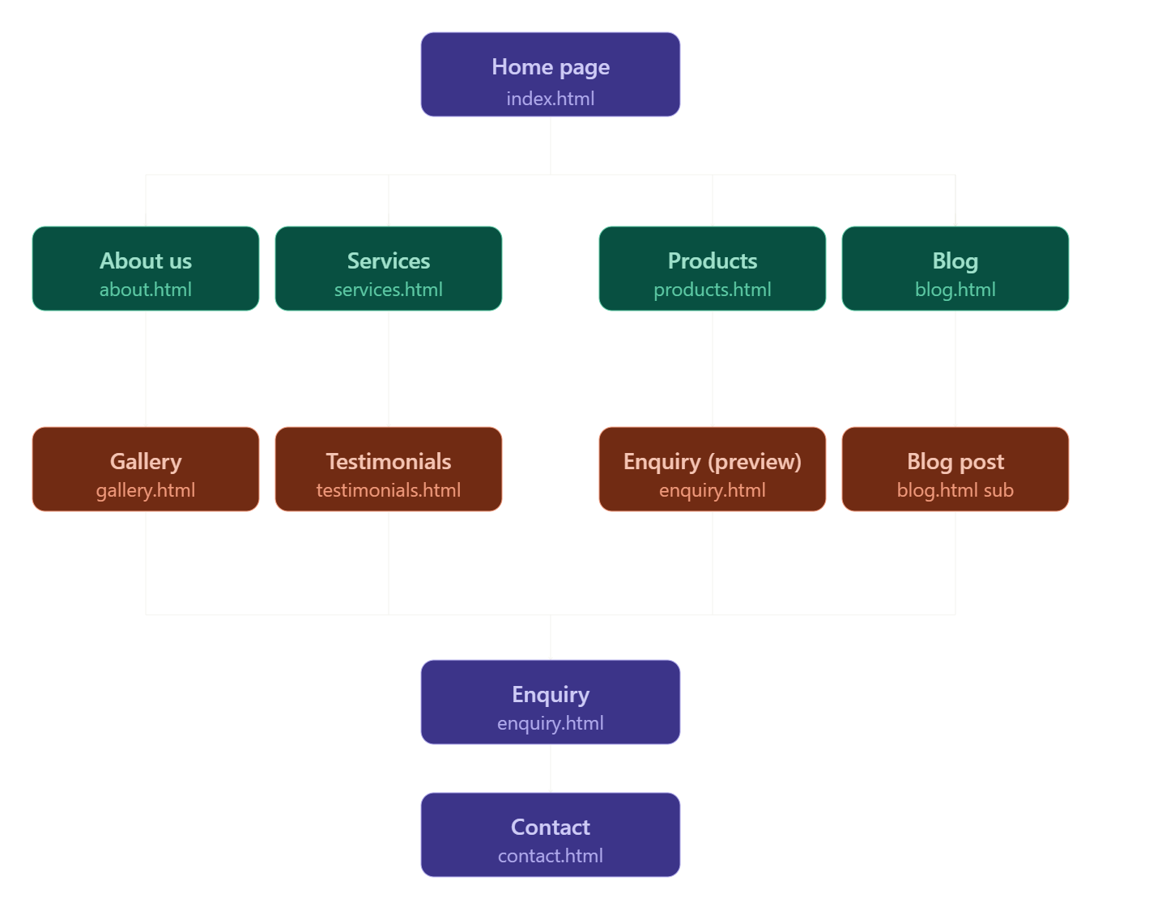

9. References
Balsamiq (2024) Balsamiq Wireframing Tool. Available at: https://balsamiq.com/wireframes/ (Accessed: 10 January 2025).
Interaction Design Foundation (2023) What is a Wireframe? Available at: https://www.interaction-design.org/literature/topics/wireframing (Accessed: 10 January 2025).
Kotler, P., Keller, K.L. and Chernev, A. (2022) Marketing Management. 16th edn. Harlow: Pearson Education.
Nielsen, J. (2020) Usability Engineering. San Francisco: Morgan Kaufmann. Available at: https://www.nngroup.com/books/usability-engineering/ (Accessed: 10 January 2025).
Pay Fast (2024) PayFast Payment Solutions for South African Businesses. Available at: https://www.payfast.co.za (Accessed: 10 January 2025).
Shopify (2024) Why Sell Products and Services Together Online. Available at: https://www.shopify.com/blog/sell-services-online (Accessed: 10 January 2025).

